Spark sounds interesting to me in that it seems to be more ‘one-stop-shop’, than the other programs.

I like that it is used by major companies, providing additional information. I love that it is real time and machine learning; allowing it to grow develop over time with greater efficiency.

Spark also uses major libraries adding to the ease and accuracy of information.

Sparks build allows for seamless interactions.

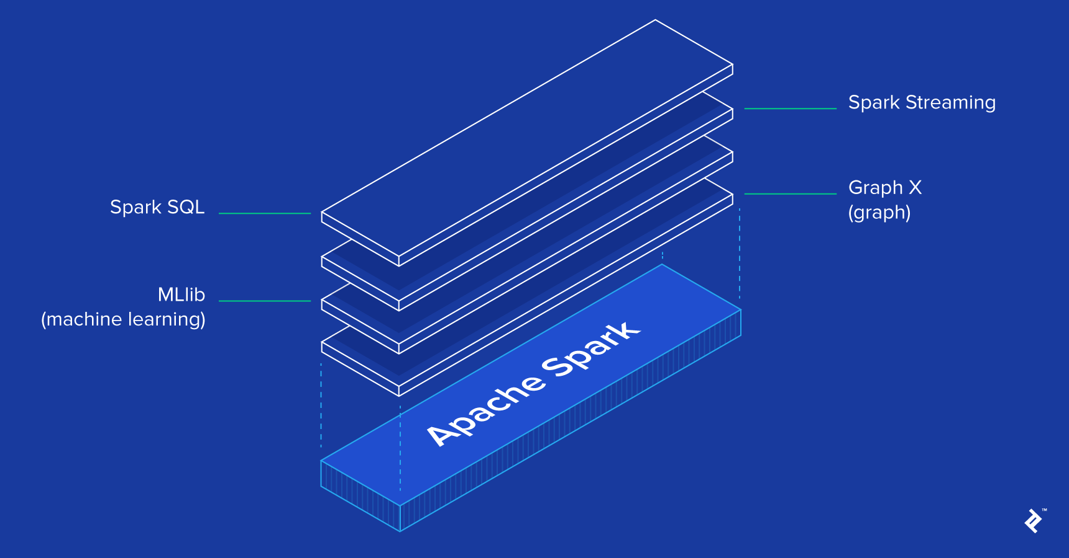

-https://www.toptal.com/spark/introduction-to-apache-spark